
BUSINESS REQUIREMENTS DOCUMENT

Project Name
Explicit IMTs on Channels -MoneyGram

Document Version: 3.0

Date:
1st, July, 2024
HEAD OFFICE

Immeuble Equity BCDC
16, Boulevard du 30 Juin, Commune de la Gombe, Kinshasa, R. D. Congo Email : mail@equitybcdc.cd

Author:
Janny M. Tshibangu

Website : www.equitygroupholdings.com/cd

CONFIDENTIALITY DISCLAIMER

THIS DOCUMENT AND THE INFORMATION IN IT ARE PROVIDED IN CONFIDENCE, FOR THE SOLE PURPOSE OF EQUITY BANK LIMITEDAND MAY NOT BE DISCLOSED TO ANY THIRD PARTY OR USED FOR ANY OTHER PURPOSE WITHOUT THE EXPRESS
WRITTEN PERMISSION OF EQUITY BANK LIMITED. ANY FORM OF REPRODUCTION, DISSEMINATION, COPYING, DISCLOSURE, MODIFICATION, DISTRIBUTION AND OR PUBLICATION OF THIS MATERIAL IS STRICTLY PROHIBITED.

TABLE OF CONTENT

- INTRODUCTION 4
  - Revision History 4
  - Document Purpose 4
  - I.4 Intended Audience. 4
- PROJECT SUMMARY 4
  - Project Background 4
  - In Scope 5
  - Out of Scope 5
  - Assumptions & Constraints 5
  - Business Context Diagram 5
  - Current process overview 6
  - Use Case Model 6
HIGH LEVEL REQIUREMENTS 7
  - High Level Requirements 7
  - User Profile 8
  - Summary of Business Rules 9
DETAILED FUNCTIONAL REQUIREMENTS 10
- Reporting 18
SIGNOFF 19

TABLE OF FIGURES

Table 11: Sign Offs 19

INTRODUCTION

Revision History

Revision date | Version | Done by | Summary of Changes
31.03.2021 | Version 1.0 | Janny MULANGA | First Draft Explicit IMTs on Channels
13.12.2022 to | Version 2.0 | Emmanuella MPUNGA | Second Draft Explicit IMTs on Channels
21.12.2022 | Version 2.0 | - Janny MULANGA  - Bobo MAKUNDA | Review Second Draft Explicit IMTs on Channels
01.07.2024 | Version 3.0 | Janny MULANGA | Explicit IMTs on Channels: MoneyGram

Document Purpose

While creating new revenue opportunities for the Bank, the aim for the International Money transfer (IMT) solutions is to also to provide innovative services to customers in other to improve their experience with the bank. This document gives detailed requirements for the MoneyGram hosted solution to be integrated into the Bank’s system.

Intended Audience

The intended audiences for this document include but not limited to:

- Business Owners | - System Designers & solution architects
- Project Manager | - Developers
- Quality Assurance | - Compliance team

PROJECT SUMMARY

Project Background

Traditional Money Transfer Operators (SWIFT, etc) are great but have limitations that directly impact the customer experience such as:
- High cost
- Slow/long processing time
- Time constraint

Committed to growth and expand global footprint in previously untapped corridors, the Bank’s objective is to offer digital money transfer services in other to reduce significantly the above IMTs “market challenges” and thus increase customer offering and experience to all sending & receiving countries. MoneyGram is in the category of integration partners that we call explicit IMTs because they of the need to display them individually on the bank’s digital platforms menu. Once integrated this category of partners will be displayed on channels (mobile apps, web and chatbot) and the customer/sender will choose through which partner he would like to send money to his beneficiary.
  - In Scope
- MoneyGram’s following Module
  - Send Module: Cash (10 min Service), Bank deposit, Wallets and home delivery
  - Receive Module : Bank account and wallet
  - Amend Module: Modification and Reimbursement of transactions
  - Terms and Conditions Menu

- P2P, B2P, B2B and P2B Outbound and Inbound via:
      - Online Banking (Easynet, EazzyBiz, One Equity).
      - Mobile Banking (USSD, Chatbot – Telegram).

- Standard API for FINTECH and TELCOS to consume

  - Out of Scope
    - Trainings
    - Commercials
    - Legal & regulatory
  - Assumptions & Constraints
    - Partners can support and process transaction in real time
    - Have all the necessary internal support and resources allocated to this development
    - Business requires this to be live by Q3 2024
2.5. Current process overview
Below are the current flow On Telegram

- Inbound Flow
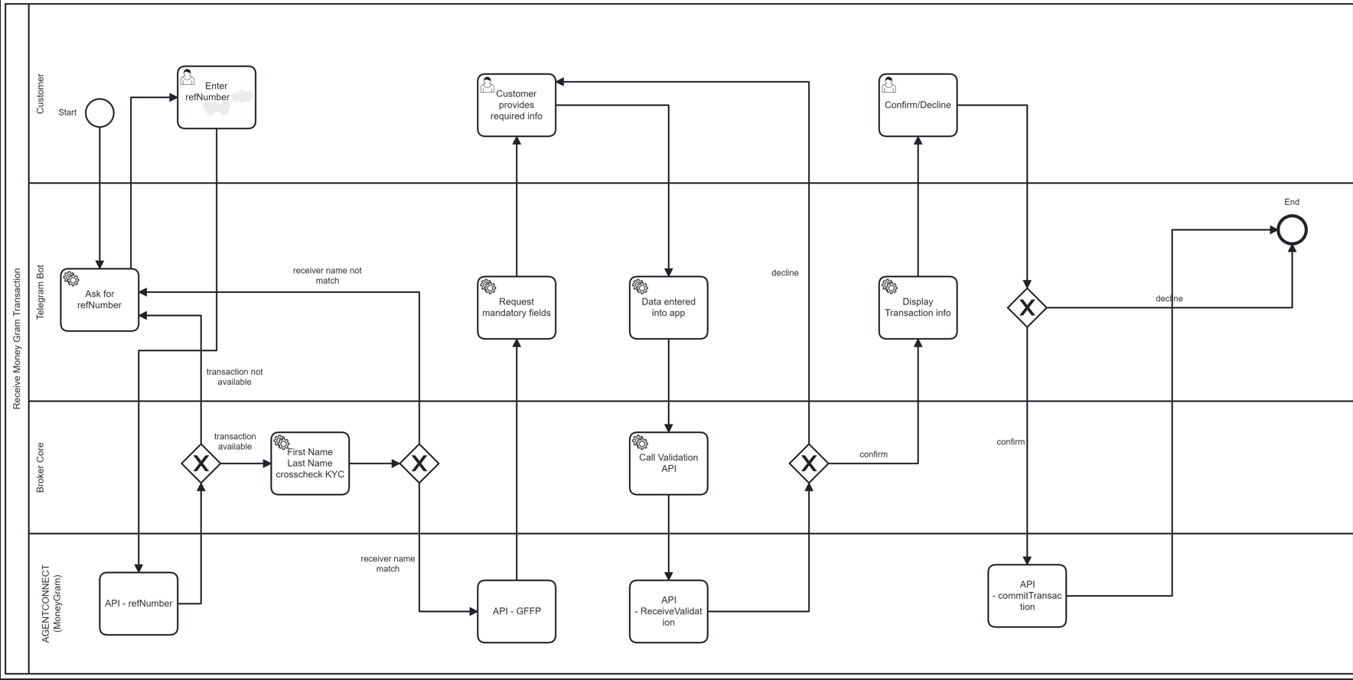
- Outbound Flow

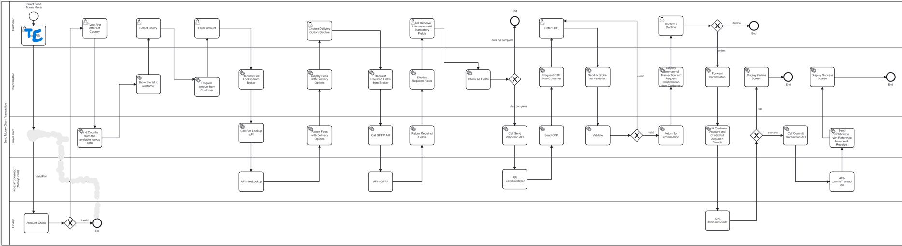
Note: After displaying success notification on the screen, a PDF receipt is sent to the customer within the application.

2.6. Transaction Flow per Channel
Equity will consume partner’s API for both Inbound and Outbound transfers.
    - Equity will send a payment instruction to the partner, which should include beneficiary identification details (first and last name, account identifier, etc.) and transaction details (amount of the operation, purpose MTCN, etc.). With the information shared, the partner will be able to route the transaction to the right beneficiary.
    - For outbound, the details requested from the customer may vary from one corridor to another. Therefore, the information displayed in the platform (chatbot, app, etc) should be dynamic (only mandatory field should be shown to the customers).
    - MoneyGram would then process the transaction and send a confirmation to EquityBCDC for each successful transaction processed. For bank deposit – the customer’s account should be credited
    - If, for any reason, the partner is unable to successfully process a payment instruction, he should notify EquityBCDC and provide the reason for the failure.

- Customer Send Journey in Telegram

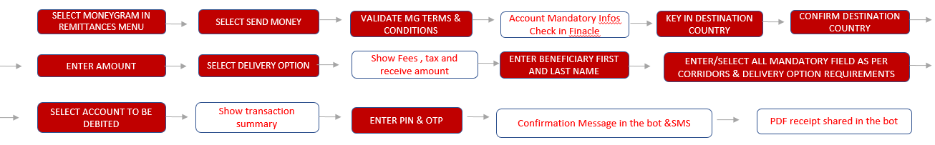

- Customer Receive Journey in Telegram

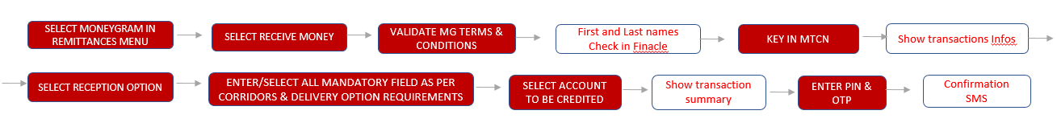

- Transaction Amend Journey in Telegram

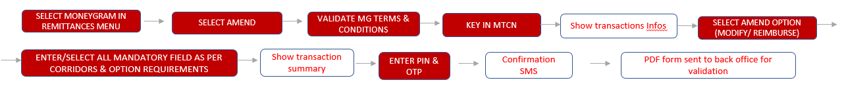

- MoneyGram Terms and Conditions Flow in Telegram

HIGH LEVEL REQIUREMENTS
2.9. High Level Requirements

FR ID. | Source | Description | Priority/  MoSCoW | Change History
FR_1 | Business  Teams | - EBCDC customers can debit account or wallet to send money abroad to a bank account, mobile wallet, a cash pick up or Home delivery location using the Bank’s internet and mobile banking (– USSD, Telegram, OneEquity and other mobile apps available in the bank) | High/Must Have | Initial
FR_2 | Business  Teams | - Enable the customer to upload documents in case needed | High/Must Have | Initial
FR_3 | Business  Teams | - Customer should receive a pdf receipt (with all transaction details) for every sent transactions in the system (chatbot, app, etc). Receipt should respect the below format | High/Must Have | Initial
FR_4 | Business Teams | Notifications: Customer should receive notifications on SMS or email for any transaction that he has initiated or received  - For outbound transaction, the customer should always receive a notification via SMS or email (depending on the channel used) at the end of his transaction.  - For incoming transaction, the customer should always receive a notification via SMS or email when his account is credited. | High/Must Have | Initial
FR_5 | Compliance  Teams | - All transactions should be screened in real time via AML Screening tools available in the bank:  - Transactions are screened against a database of sanctioned names (receiver names, sender names, and country). The database is saved on the AML data dump that is regularly updated  - Only transactions that receive a positive score after hitting the AML database bump and screen should be processed  - if a transaction receive a negative score after hitting the AML database Bump and screen, it should not be processed and a feedback should be sent to the partner (inbound) or to the Branch (outbound) | High/Must Have
FR_6 | Business  Teams | - Failed or declined transactions should be reversed automatically to the sender/the party initiating the transaction | High/Must Have | Initial
FR_7 | Business  Teams | - The transaction common identifier/reference (for EBDCD and the partner) should be capture in the narration  - Example of Narration parts  - For Principal amount: “Transfer reason/IMT name /IMT and EBCDC Common Reference Number”  - For FX income: “FX/ IMT name /Trx Finacle ID”  - For Commission: “Fees Name/ IMT name /Trx Finacle ID”  - For RSC: “RSC/IMT Name/ Trx Finacle ID”  For IMT partner processing Fees: “Correspondent Fees/IMT name/Trx Finacle ID” | High/Must have | Initial
FR_8 | Business Teams | - For both outbound and inbound the system should generate a daily transaction report that contains the following details:  - Sender’s name  - Sender’s account number (for transaction initiated on digital platform) or phone number for OTC  - Recipient Name  - Recipient country  - Recipient’s bank info (account number or Iban) or mobile number  - Transaction Amount  - Fees and income: partner settlement fees, bank commission, FX income  - Date of transaction  - Transaction reference number  - Branch (for transactions initiated over the counter)  - State whether a transaction was initiated via mobile banking, internet banking or branch (OTC) | High/Must Have | Initial
FR_9 | Business Teams | - For failing inbound and outbound transactions, the system should generate an incident report showing clearly reasons why a transaction did not go through | High/Must Have | Initial
FR_10 | Business Teams | - For failing transactions, customer should receive different types of messages in the bot based on error type: system errors or validation errors  Finacle data validation errors message  We’re unable to process your request. Please visit the nearest Equity branch to update your bank account personnal data. (Votre requête ne peut pas être traitée. Rendez -vous dans une agence Equity pour mettre à jour les données personnelles de votre compte.)  System Errors  We're Unable to process your request at the moment. Please  try again later. (Votre requête ne peut pas être traitée pour l’instant. Veuillez réessayer plus tard.)  Validation Errors  Your transaction cannot be processed. Please make sure you enter correct data (e.g. IBAN, names, number, address, etc) /(Votre transaction ne peut pas être traitée. Assurez-vous que les données insérées sont correctes (ex. IBAN, noms, numéro, adresse etc) | High/Must Have | Initial
FR_11 | Business Teams | - Auto conversion capabilities to allow reception or sending in different currencies | High/Must Have | Initial
FR_12 | Business Teams | - Transactions limits are as follow:  - Bank account (Inbound and outbound): 7500$ per transactions, and 9900$ per day  - ATM (Inbound): 500$  - Cash (inbound and outbound): 7500$  - Wallets (inbound and outbound): 2500$  These limits are subject to change according to market conditions and regulations. Therefore, there should be room for adjustments without requiring a new development. | High/Must Have | Initial
FR_ 13 | Business Teams | - Transactions tariffs are given by MoneyGram in the API | High/Must Have | Initial
FR_14 | Business Teams | The bank system should support both French and English.  - In the French version, all information (countries, purpose, etc) should appear un French  - In the English version, all information should appear as well in english | High/Must Have | Initial
FR_15 | Business Teams | For transactions amend module, the pdf form send to back office should respect the attached format | High/Must Have | Initial
FR_16 | Business Teams | The below text should be hosted by the bank for redirection when customer click on the terms and conditions link | High/Must Have | Initial
FR_17 | Business Teams | Transfer reason requiring a license should not be shown in the drop list menu for selection | High/Must Have | Initial

2.10. User Profile

Category | Computer Experience level | Existing Computer Skills and  Experience | Typing Skills | Application Domain Knowledge | Device Used | Native Language
Partners | Intermediate to Expert | Broad range of skills and experiences | Good to Excellent | Knowledgeable to Highly trained in the  domain | Desktop computer, Mobile  device | May or may not be an English  speaker
Business Teams | Intermediate to Expert | Broad range of skills and experiences | Good to Excellent | Knowledgeable to Highly trained in the domain | Desktop or Laptop computer, Mobile,  device | English speaker
IT Operations | Expert | Broad range of skills and experiences | Good to Excellent | Highly trained in the domain | Desktop or Laptop computer, Tablets, mobile  device | English Speaker
Equity Bank Systems | Expert | Broad range of skills and experiences | Good to Excellent | Knowledgeable to Highly trained in the  domain | Desktop computer, Mobile  device | May or may not be an English  speaker

2.11. Summary of Business Rules

Business  Rule Id | Rule Name | Rule Description | Rule Source
BR001 | Limitation rule | Message sent/receive should meet the SWIFT /IMT  Standard | Central Bank
BR002 | Process rule | All transactions should be screened in real time via compliance and risks screening tools available in the bank | AML
BR003 | Process rule | Partners should send out a different notification/message for incoming and outgoing transactions and per failing reasons | Business
BR004 | Process rule | Conditions to decline a transaction:  - High value transactions (above defined limit)  - Insufficient balance  - Mismatch of customer’s name and account or lack of certain mandatory information in finacle  - Incorrect beneficiary details  - Blacklisted accounts | Business
BR005 | Process rule | Fees and commissions will apply as MoneyGram tariff. | Business
BR006 | Process rule | Failed or declined outbound transactions should be reversed automatically to the sender include fees | Business
BR007 | Process rule | The system should automatically process or reroute a transaction to the partner that offers EBCDC the lowest charges and quotations for a given corridor | Business
BR008 |  | A pdf receipt should be generate in the bot or app after every sent transaction | Business
BR009 |  | Transfer reason requiring a license should not be shown in the drop list menu for selection | Business

DETAILED FUNCTIONAL REQUIREMENTS

Requirement 01 | Sending money to a beneficiary abroad using Telegram
Actor(s) | EquityBCDC Customer, Equity Bank Systems, and MoneyGram system
Use Case Overview | Equity BCDC customer is sending international money transfer to a beneficiary abroad through Chatbot
Precondition 1 | Customer must subscribe to mobile banking to access the chatbot
Precondition 2 | Customer must log into the chatbot
Termination outcomes |  |  | Condition Affecting Termination Outcomes
Transaction successful |  |  | - Mobile Banking Credentials activation in the system  - Valid/correct beneficiary details  - Approved/Validated PIN  - Approved/validated one time password  - Funds available in the bank account selected  - Selected channel and corridor are available in the specific chatbot  - System is operational at the time of the transaction
Transaction failure |  |  | - Incomplete KYC mandatory Infos in the system  - Invalid/wrong login credentials  - Invalid/incorrect beneficiary details  - Invalid PIN  - Invalid one-time password  - Insufficient funds in the account selected  - Selected channel and corridor are not available in the specific chatbot  - System is not operational at the time of the transaction
Description of Termination outcome #1 |  |  | Customer will log in to the Chatbot, he will select MoneyGram and then send money  An auto KYC check will happen in the backend and after that, customer will be requested to accept the MoneyGram T&C before proceeding and then follow the instructions as per the flow described above.  After completing all the mandatory infos, the customer will then be asked to verify that the details he inserted are correct and confirm his transaction, by inserting his PIN and/or the one-time password (OTP) he received via SMS through the phone number linked to his EquityBCDC bank account.  The transactions summary should be as follow:
 |  | 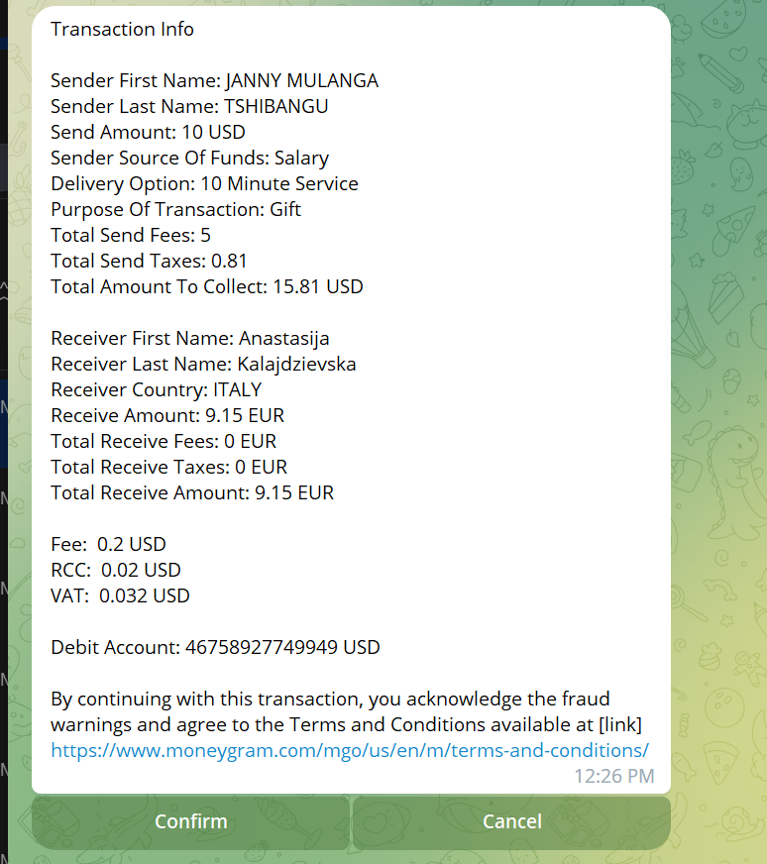

Description of Termination outcome #2 | The transaction will end  - If the customer’s mobile banking is not activated  - If some mandatory KYC Infos are missing  - If the customer has not received the one-time password (OTP).  - If the customer inserts the wrong or an expired PIN and/or one-time password (OTP)  - If the customer does not confirm the recipient details.  - If the customer has insufficient funds.
Use Case Associations | Customer can only do one transaction at a time.
Business Rules | Access to Chatbot requires Mobile banking activation and PIN validation
Inputs Summary | Name, Amount, Mobile Number, Transaction purpose
Output Summary | SMS and email notification, Pdf receipt
Reports | The system should generate a report of every transaction that includes the following info:  - EBCDC’s reference number  - Partner’s reference number  - Name of the partner/operator that processed the transaction  - Date and time  - Sender’s name  - Beneficiary details

Requirement 02 | Receiving money from abroad using Telegram
Actor(s) | EquityBCDC Customer, Equity Bank Systems, and MoneyGram system
Use Case Overview | Equity BCDC customer is receiving international money transfer from abroad on his bank account through  Chatbot
Precondition 1 | Customer must subscribe to mobile banking to access the chatbot
Precondition 2 | Customer must log into the chatbot
Termination outcomes |  |  | Condition Affecting Termination Outcomes
Transaction successful |  |  | - Mobile Banking Credentials activation in the system  - Valid/correct account details  - Approved/Validated PIN  - Approved/validated one time password  - Registered MTCN Available for payment  - System is operational at the time of the transaction
Transaction failure |  |  | - Invalid/wrong login credentials  - Invalid/incorrect accounts details  - Invalid PIN  - Invalid one-time password  - MTCN not available for payment  - System is not operational at the time of the transaction
Description of Termination outcome #1 |  | Customer will log in to the Chatbot, he will select MoneyGram and then receive money  An auto KYC check will happen in the backend and after that, customer will be requested to accept the MoneyGram T&C before proceeding and then follow the instructions as per the flow described above.  After completing all the mandatory infos, the customer will then be asked to select the account to be credited, and confirm his transaction, by inserting his PIN and/or the one-time password (OTP) he received via SMS through the phone number linked to his EquityBCDC bank account.  The transactions summary should be as follow:  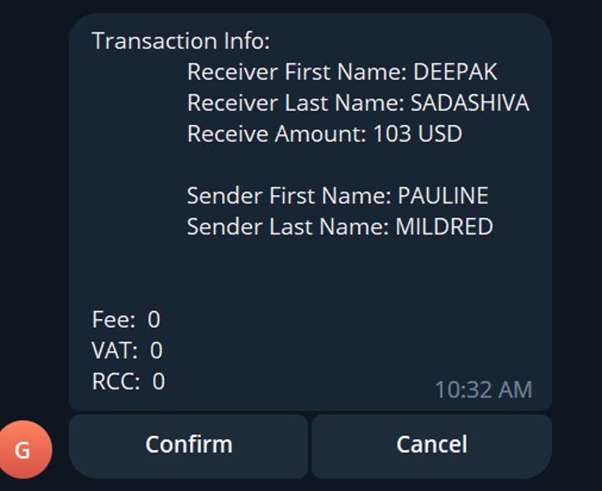
Description of Termination outcome #2 |  | The transaction will end  - If the customer’s mobile banking is not activated  - In case of Mismatch between beneficiary and customer name  - If the customer has not received the one-time password (OTP).  - If the customer inserts the wrong or an expired PIN and/or one-time password (OTP)  - If the customer does not confirm the recipient details.
Use Case Associations |  | Customer can only do one transaction at a time.
Business Rules |  | Access to Chatbot requires Mobile banking activation and PIN validation
Inputs Summary |  | MTCN
Output Summary |  | SMS and email notification
Reports |  | The system should generate a report of every transaction that includes the following info:  - EBCDC’s reference number  - Partner’s reference number  - Name of the partner/operator that processed the transaction  - Date and time  - Sender’s name  - Beneficiary details

Reports | The system should generate a report of every transaction that includes the following info:  - EBCDC’s reference number  - Partner’s reference number  - Name of the partner/operator that processed the transaction  - Date and time  - Sender’s name  Beneficiary details

Requirement 03 | Amend a transaction
Actor(s) | Equity BCDC Customer, Equity Bank Systems and back Office and MoneyGram
Use Case Overview | Equity BCDC customer wants to correct a transaction or ask for a refund
Precondition | Customer must have the transaction reference number
Termination Outcomes | Condition Affecting Termination Outcomes
Registration successful | Correct reference Number, status of the transaction
Registration failure | Invalid reference number, status of the transaction
Description of Termination outcome #1 | Customer will log in to the Chatbot, he will select MoneyGram Amend transaction menu and then follow the instructions as per the flow described above.  After completing all the mandatory infos, the customer will then be asked to confirm his request by inserting his PIN and/or the one-time password (OTP) he received via SMS through the phone number linked to his EquityBCDC bank account.  After confirmation, the customer request will be then sent automatically to remittances back office for validation.
Description of Termination outcome #2 | The reversal will not be successful:  - If the customer does not have the correct reference number.  If the details initially provided were correct.
Use Case Associations | Customer can only reverse one transaction at a time
Business Rules | - Customer must have a reference number  Customer must confirm reversal details
Inputs Summary | Reference Number
Output Summary | SMS and email notification, pdf amend form sent to back office
Reports | The support team should generate daily reports of complaints including  - Customer’s name  - Purpose of his complaint  - Status of his complaint  - Transaction reference  - Date and time of the complaint  Date and time of treatment

Reporting
Make available to the customer the following reports/files as outlined in the Mastercard Send Cross- Border Product Guide.

Report Name | Description | File Transfer Bulk ID | Occurrence or Timing
Settlement Reconciliation File | Provides all information necessary to reconcile Mastercard Send settled transactions. Pending or  declined transactions not included. | Test: TX39  Production: TX37 | Once per day when there are settled transactions. All transactions will be grouped by currency but included in one file
Daily Transaction Report | Provides detailed transaction information for transactions aligning to the cutoff for the previous day | Test: T6J6  Production: T6J4 | Daily around 9:30 pm (CST) Contains transactions from 8 PM previous day through 7:59  PM current day
Status Change Report | Provides detailed transaction information for transactions where a status has changed since the initial  transaction status was reported. | Test: T6J2 Production: T6J0 | Daily at 4 intervals  5 am, 11 am, 5 pm and 11 pm (CST)
Net Settlement Advisement (optional) | Provides net settlement positions by ICA via Mastercard Connect, Email or Fax (not necessary for this product) | N/A | N/A
Incident report | Provides list of transactions that has failed and reasons for failure

SIGNOFF

The undersigned acknowledge they have reviewed and approved of the Business requirements for MoneyGram on Channel program. Any changes to these Requirements will follow defined requirements change management process.

Business sign offs
Name | Title | Signature | Date
Emmanuella MUAMBA | Project Manager
Janny MULANGA | Country Head International Banking
Jeremy LUKUSA | Associate Director Payments

Other sign offs
Name | Title | Signature | Date
Joe MUTOMBO | Business Product Innovation
Bobo MAKUNDA | Head of System Applications
Charmant MAMBUKU | Head of Infrastructure and Technology
Innocent HATEGEKIMANA | CIO/DRC

